# Installation of NLTK

## STEP – 1: pip install nltk

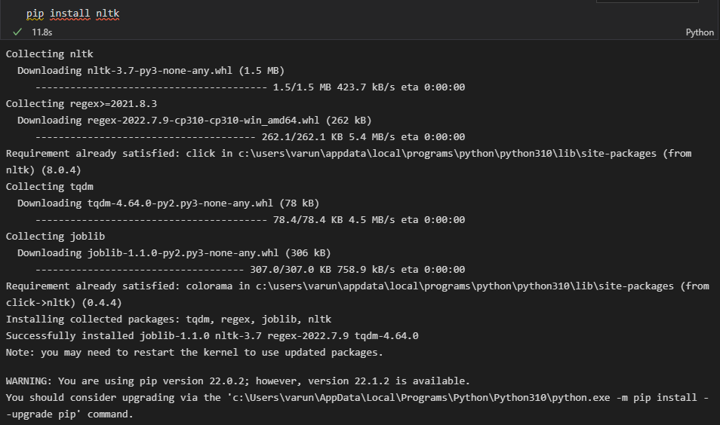

## STEP – 2: pip install -U numpy

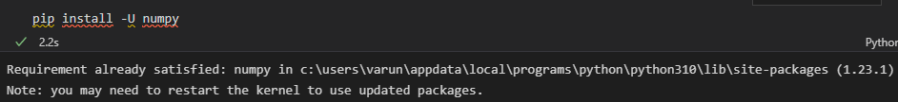

## STEP – 3: pip install -U nltk

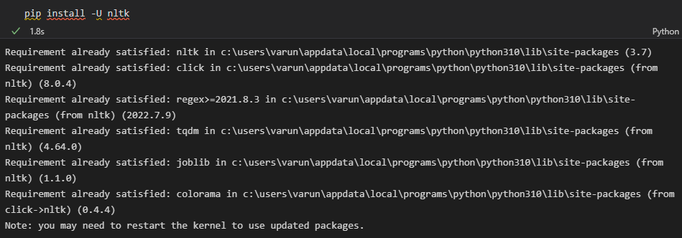

# Unigrams

To generate 1-grams we pass the value of n=1 in ngrams function of NLTK. But first, we split the sentence into tokens and then pass these tokens to ngrams function.

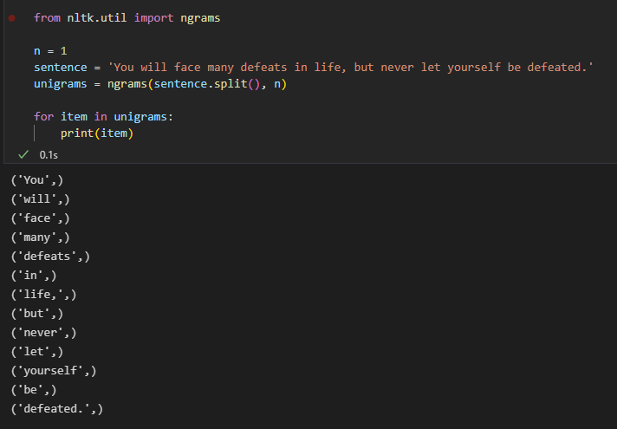

# Bigram

Some English words occur together more frequently. For example - Sky High, do or die, best performance, heavy rain etc. So, in a text document we may need to identify such pair of words which will help in sentiment analysis. First, we need to generate such word pairs from the existing sentence maintain their current sequences. Such pairs are called bigrams. Python has a bigram function as part of NLTK library which helps us generate these pairs.

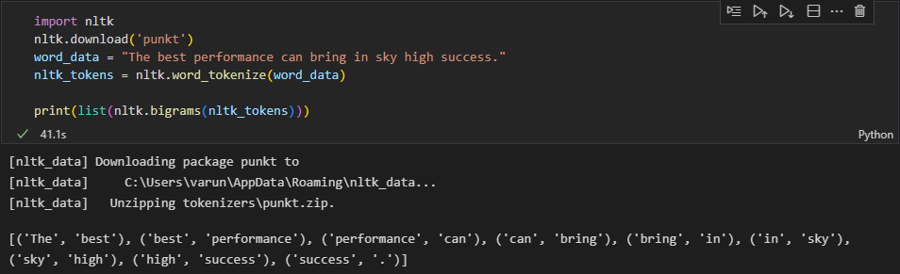

# Trigram

In case of 3-grams, we pass the value of n=3 in ngrams function of NLTK. But first, we split the sentence into tokens and then pass these tokens to ngrams function.

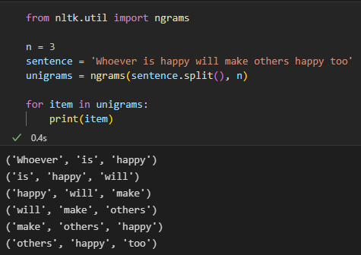

# Everygram

NTK provides another function everygrams that converts a sentence into unigram, bigram, trigram, and so on till the ngrams, where n is the length of the sentence. In short, this function generates ngrams for all possible values of n.

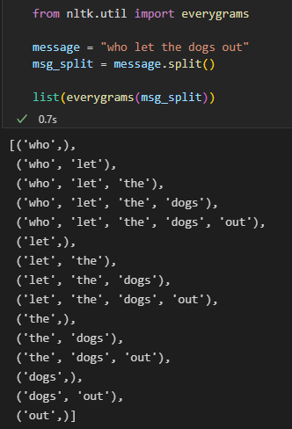

# Ngrams